**DBMQP MINI PROJECT**

* **PROJECT TITLE: *Banking System***
* **ER DIAGRAM:**

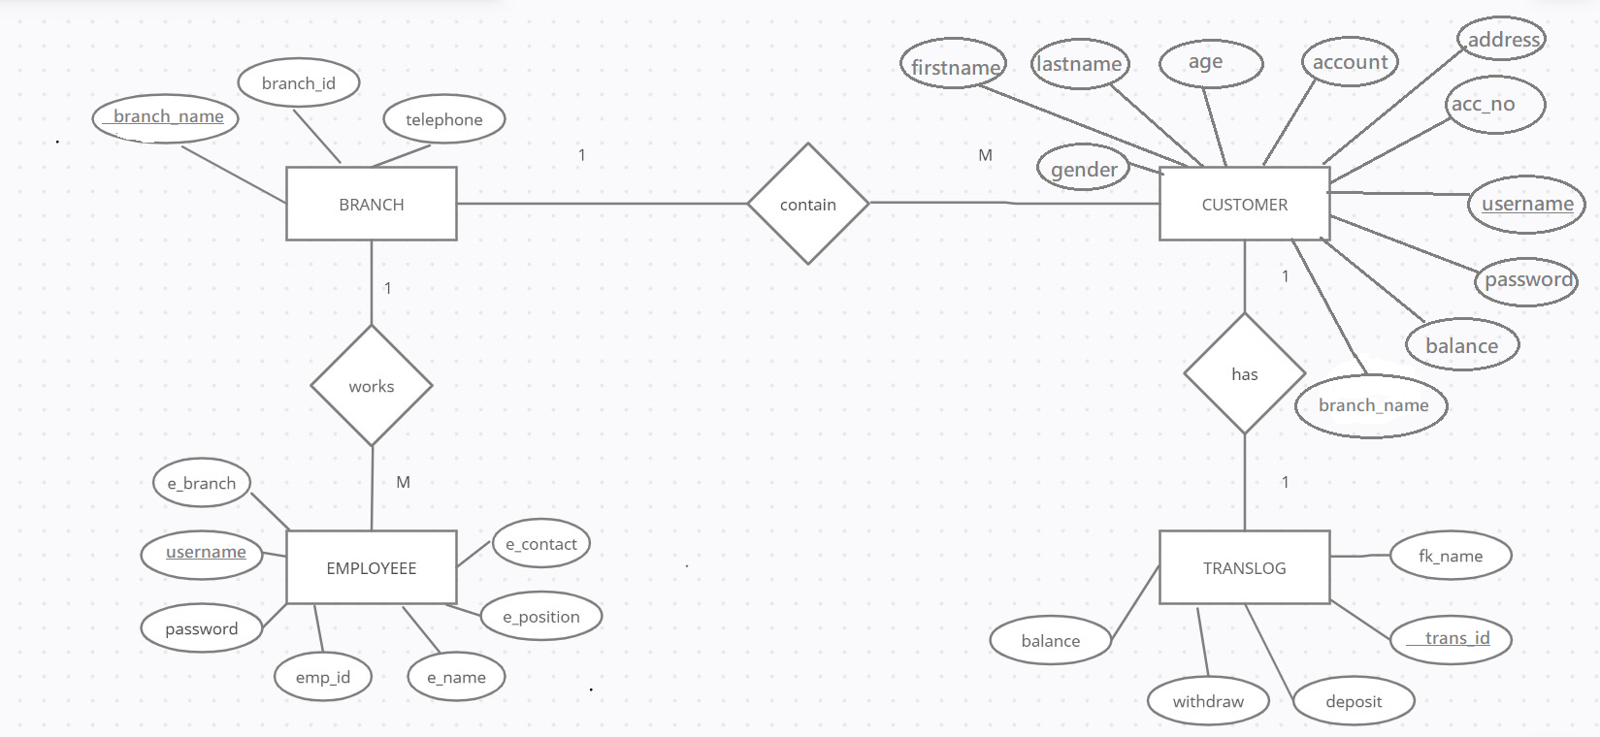

* **CONVERT ENTITY RELATIONSHIP DIAGRAM TO RELATIONS**

**RELATIONS WITH DATA:**

CustomerContains(Username,password,firstname,lastname,age,gender,account,address,accountnumber,balance,branch_name)

Branch(branch_name,branch_id,telephone)

EmployeeWorks(UserName,password,emp_id,e_name,e_position,e_branch)

Trans_log(Trans_ID,deposit,withdraw,Bal,FK_uname)

Has(trans_ID,Username)

* **CREATE TABLES**

CREATE TABLE branch (

branch_id int(10) DEFAULT NULL,

branch_name varchar(20) NOT NULL,

telephone int(7) NOT NULL

);

CREATE TABLE customer (

firstname varchar(30) DEFAULT NULL,

lastname varchar(30) DEFAULT NULL,

age int(3) DEFAULT NULL,

gender varchar(10) DEFAULT NULL,

account varchar(30) DEFAULT NULL,

address varchar(30) DEFAULT NULL,

accountnumber int(10) DEFAULT NULL,

username varchar(30) NOT NULL,

password varchar(30) DEFAULT NULL,

balance int(30) DEFAULT NULL,

branch_name varchar(20) DEFAULT NULL

);

CREATE TABLE employee (

UserName varchar(30) NOT NULL,

Password varchar(10) NOT NULL,

emp_id int(5) NOT NULL,

e_name varchar(20) NOT NULL,

e_position varchar(15) NOT NULL,

e_contact int(10) NOT NULL,

e_branch varchar(10) NOT NULL);

CREATE TABLE trans_log (

Trans_ID int(5) NOT NULL,

Deposit int(6) DEFAULT NULL,

Withdraw int(6) DEFAULT NULL,

Bal int(6) NOT NULL,

FK_uname varchar(10) NOT NULL

);

* **INSERT DATA IN THE TABLE**

**CONNECTION:**

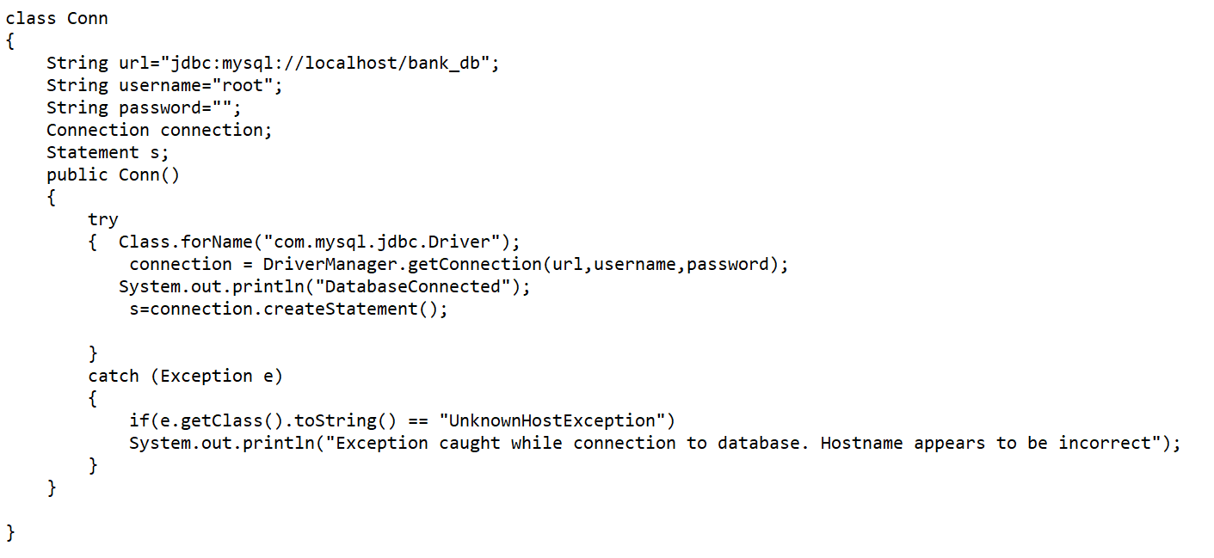

**QUERIES:**







































* **OUTPUT:**
* **Initially**

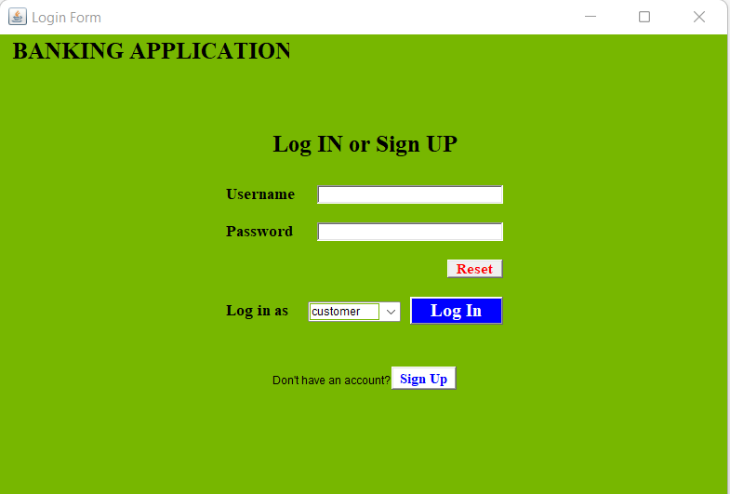

* **Signing Up**

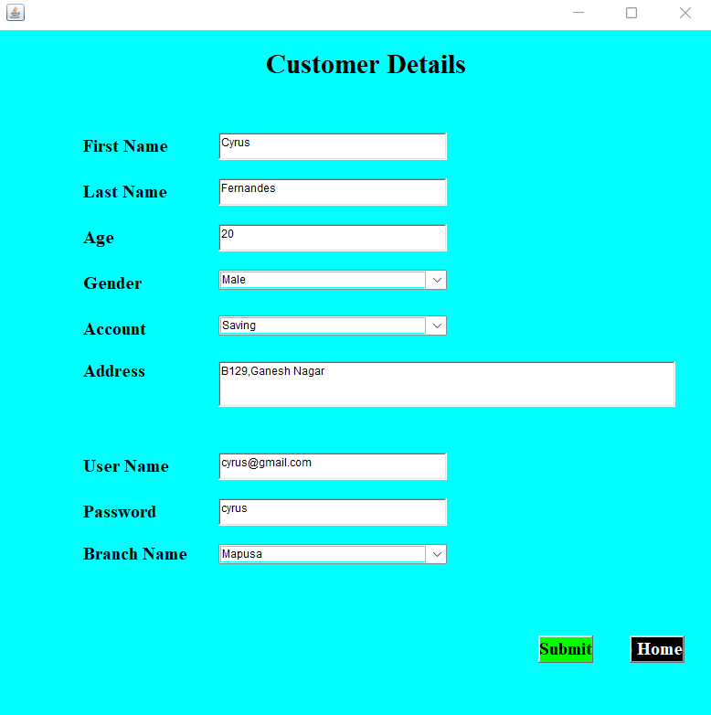

* **Logging In**

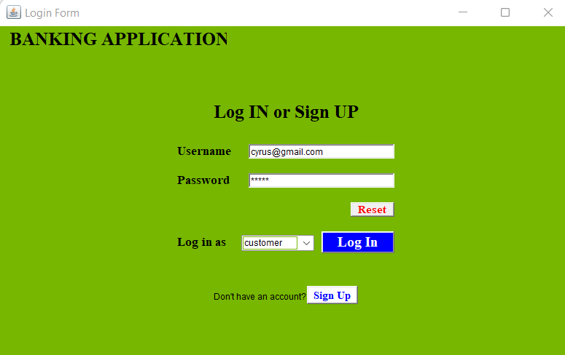

* **Customer Page**

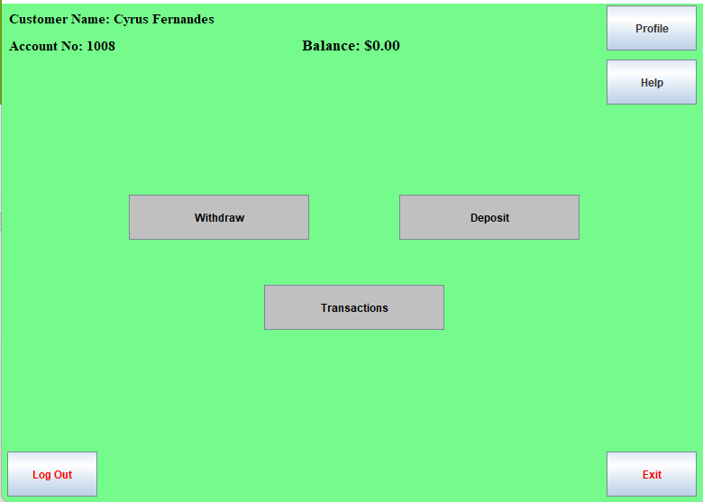

* **Account Details**

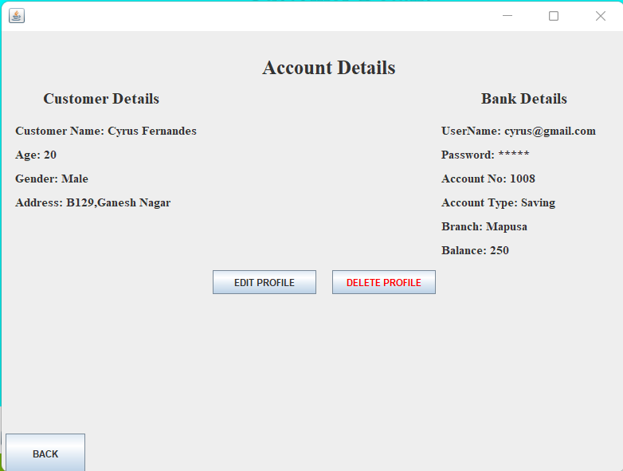

* **Delete Account:**

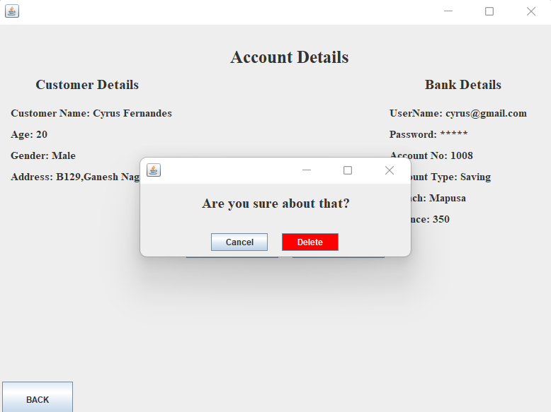

* **Help**

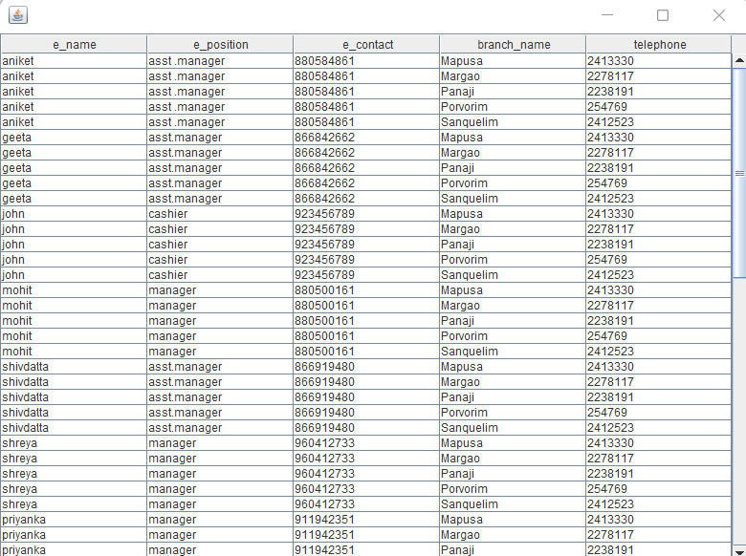

* **Withdraw**

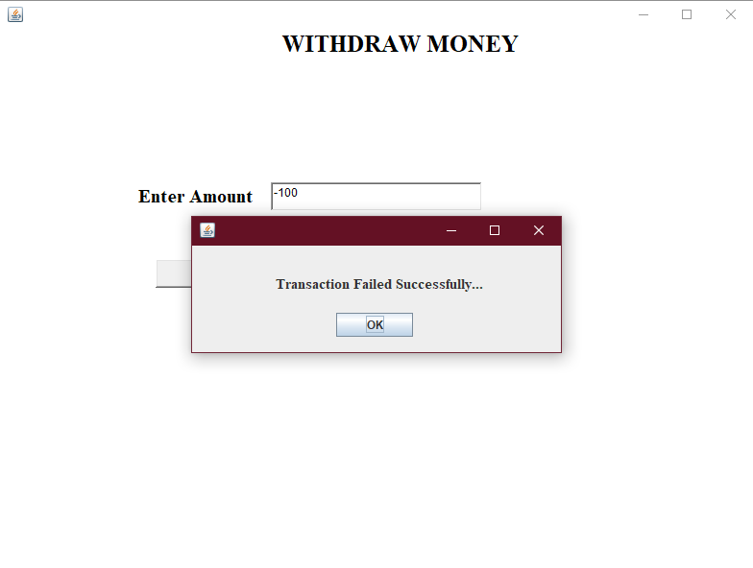

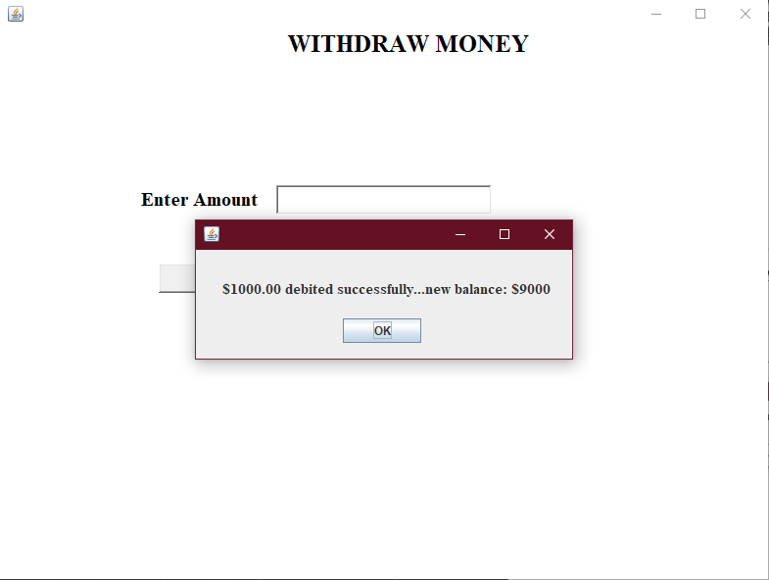

* **Deposit**

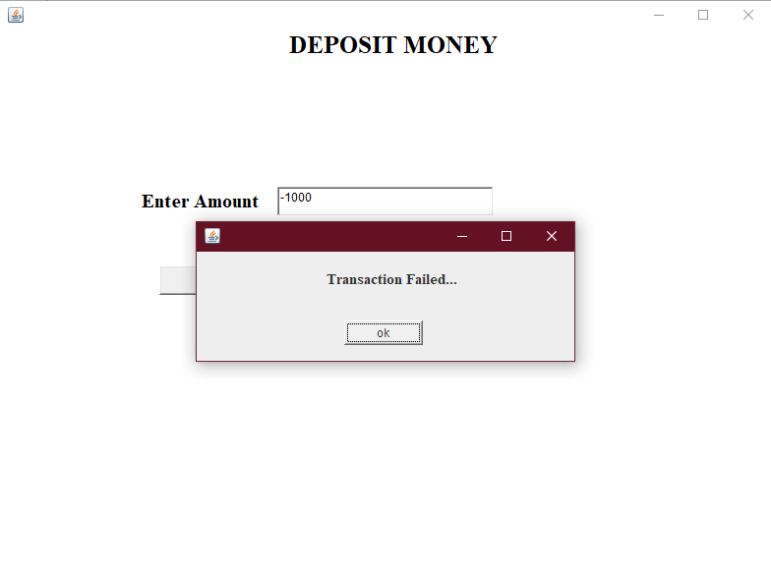

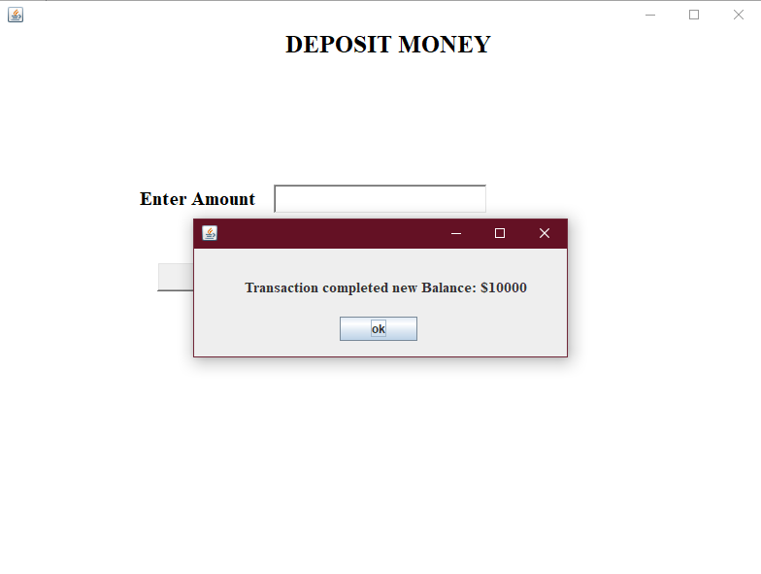

* **Transation Details:**

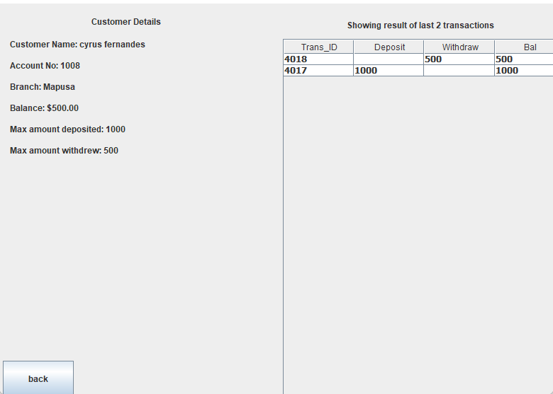

* **Logging in(As Employee)**

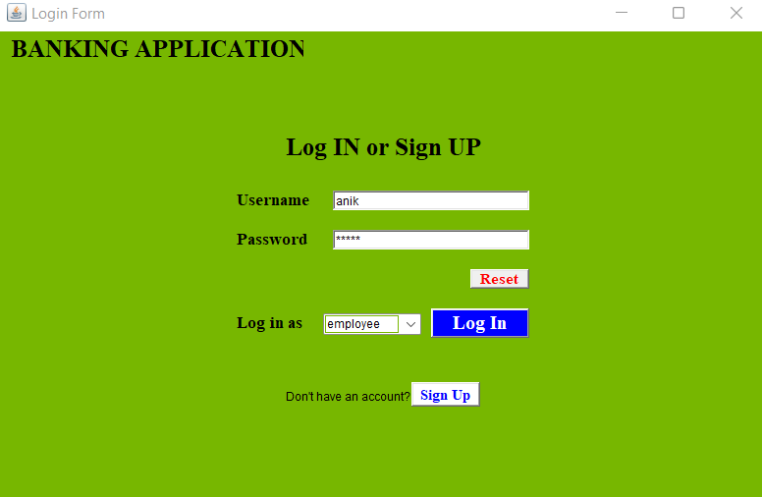

* **Employee Details :**

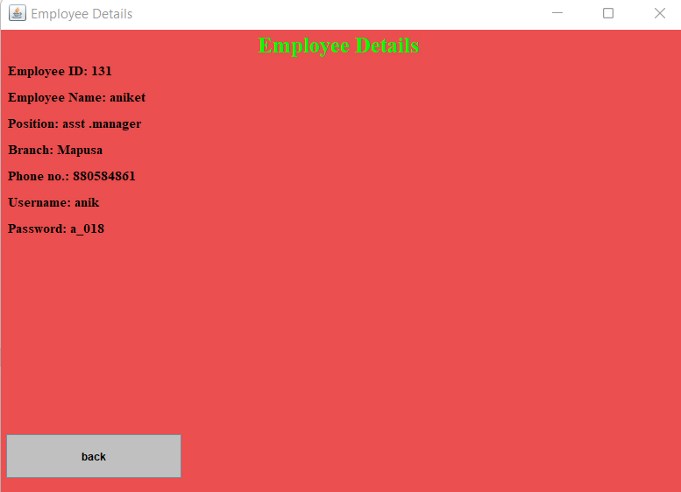

* **Exit Page**



**CONCLUSION:**

In the mini project, we learnt to represent the given problem statement into an entity relationship diagram along with cardinality and participation constraints. Then, conversion of the ER diagram to Relation which were further implemented in the database. The graphical user interface and database connection was implemented using which the data from the database could be accessed n modified. The data manipulation in the database was successfully implemented using SQL queries.